San Pancho Children Celebrate the Beat
Becci Burchett - PeaceMexico.org
February 11, 2011
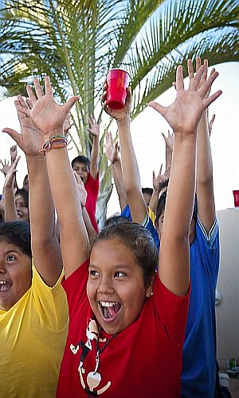
More Sharing ServicesShareShare on facebookShare on twitterShare on googleShare on buzzShare on myspace

San Francisco, Nayarit - Over one hundred third, fourth and fifth- grade students are developing pride, confidence and work ethic through Celebrate the Beat, a dance program that expanded from Punta de Mita schools to the primary school in San Pancho last week.
Professional dancers, choreographers, musicians, and composers from Colorado based Celebrate the Beat Foundation (CTB) have partnered with PEACE, a local non-profit, to provide the program.
Teachers from CTB believe that integrated arts programs create physical and mental strength that manifests itself in the classroom. The group has traveled around the US and Mexico to share their program with grade-school children.
"CTB not only increases confidence, teamwork, and self-expression, but it also increases attendance," said Nova Pennison, Director of Casa Comunidad, the education program at PEACE. "It’s a positive outlet for their energy."
$125 allows a child to be sponsored in the program for one year. For more information about sponsoring a child, please contact becci(at)peacemexico.org.
Celebrate The Beat (CTB) is a not-for-profit Colorado-based organization. Their mission is to teach inspirational music and dance classes that help children discover their potential by motivating them to believe in themselves, to value artistic expression, and to develop a personal standard of excellence; to use dance as the medium to teach children a valuable life lesson: that energy, discipline, hard work, commitment, and joyful.

PEACE, (Protection, Education, Animals, Culture, Environment) established in 2005, is a 501(c) 3 nonprofit organization made up of three main programs which focus on education, animal well-being, and environmental protection in the Bay of Banderas, Nayarit, Mexico. PEACE works hand-in-hand with communities in Mexico to provide holistic education, combined with community action programs that enable people to improve their quality of life as well as their financial stability.
For more information, please visit PeaceMexico.org or click HERE to read more about PEACE

