Home»News»News From Banderas Bay»PEACE Implements International Enterprise, Offers Women New Opportunities
Friday, 13 May 2011 13:50

PEACE Implements International Enterprise, Offers Women New Opportunities
Written by Keph Senett

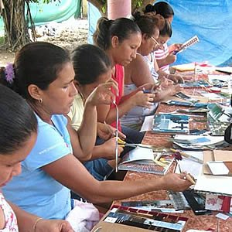ArtisansPEACE Mexico
Manos Unidas por la Mujer (United Hands for Women), a women's artisan program supported by local non-profit PEACE, has developed into the PEACE Boutique, a Mexican art distributor and social enterprise that offers women the opportunity to distribute and sell their products to stores and markets throughout North America.
Due to robust sales and international interest, PEACE has transitioned the Manos Unidas por la Mujer (MU) program from a workshop format into the PEACE Boutique, a Mexican art distributor and social enterprise. This shift means that artisans and cooperatives from small communities in Mexico get the opportunity to sell their products in stores and markets throughout North America and receive payment according to a fair trade arrangement. The artisans set their own prices, paid by the PEACE Boutique, which then distributes and sells their products. Any remaining profit, after paying the artisans, goes to PEACE, a registered 501(c)(3) non-profit organization.
In addition to the ability to impact their communities through their new-found buying power, artisans will also be able to reach a broader international audience. “We are putting a focus on groups that assist artisans in maintaining their cultural identity,” Kirkpatrick said. The PEACE Boutique is now representing the Huichol Center for Cultural Survival in Sayulita, Nayarit and an embroidery group in the mountains of Oaxaca called Chidobueno.
Co-Directors Kirkpatrick and Jennifer de la Torre will be traveling to Colorado and New York this summer to introduce the new PEACE Boutique line and develop sales through various public and private events. Venues include the Greenhorn Valley Music Festival in Colorado and the New York International Gift Fair, one of the largest wholesale markets in the world.
Organizers expect to be able to open a PEACE Boutique storefront in Puerto Vallarta with proceeds from the summer festivals. “Puerto Vallarta is strategically the best place to expose artists and generate sales over the long term,” Kirkpatrick explained. “We are very excited about the steps that have been made thus far, and to see these artists succeed worldwide!”

To sponsor the PEACE Boutique and their journey to the States, donate your frequent flier miles! Contact KT@peacemexico.org or jennifer@peacemexico.org for more information.
