Local Artisan Co-Op Goes Global
Written by Mariano Montes De Oca
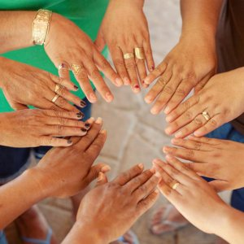PEACE - Manos Unidas por la Mujerpeacemexico.org
Local non-profit, PEACE has recently introduced PEACE Boutique, an online web store featuring a selection of hand-made items made by a group of women in the Bahia de Banderas.
Manos Unidas por la Mujer (United Hands for Women,) one of four main programs at PEACE, unites women from the Bay of Banderas, Mexico, so they can support and build each other up financially and emotionally.
These forty women create hand-made artwork made from low cost, recycled materials. With the proceeds from sales, they are able to increase their financial independence and provide for their families. Members are divided into groups according to material used (wood, paper, embroidery) and are headed by a Manos Unidas coordinator - a local woman who has shown a strong sense of leadership, responsibility, craftsmanship & pride in her work. All of the products are made with quality, not charity in mind.
Although financial benefits provide needed relief for economic stresses, the co-op has an
over-arching focus on education and camaraderie. Women participate in bi-monthly workshops focused on ecology, self-esteem, parenting and nutrition. Through this process all have become intimate friends.
“Manos Unidas is a blessing for me, because I am able to work from home and take care of my girls at the same time. I want to keep learning new things each day.”- Tere , Manos Unidas member.
To view a selection of products made by the women of Manos Unidas por la Mujer, visit www.thepeaceboutique.com. For access to the wholesale page or to request a customized order, please email theboutique@peacemexico.org.

