Girls Surf Clinic Promotes Strong Self-Esteem and Healthy Lifestyle
Written by Peace Mexico on 02 May 2011
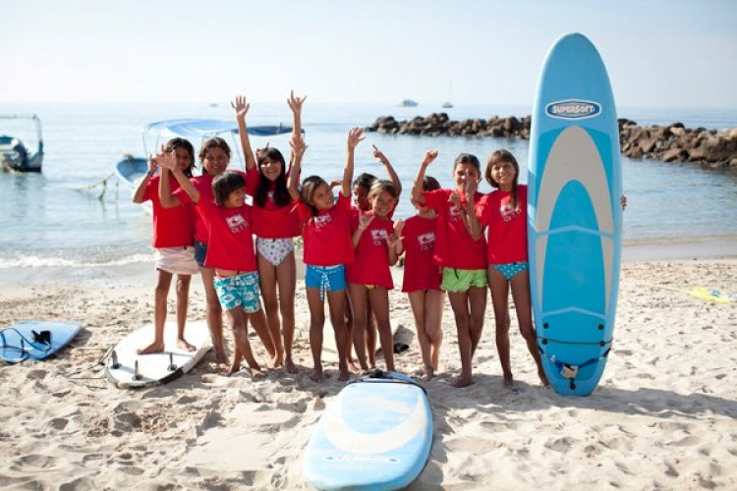
Pushing back water with cupped hands, she hears the rush of approaching water, connects with the moving force, stands up on her board in perfect balance with nature, and feels the strength of the ocean underfoot. Both body and mind are exhilarated as she conquers one clear goal – catching a wave. Now that’s empowering. This feeling glowed in more than 17 young girls on April 25, 26 and 27 during the PEACE + Wahine Project surf clinic.
The Wahine Project is an educational program for girls between the ages of seven and seventeen who do not have the geographical or financial opportunities to surf. The project seeks to introduce the invigorating sport of surfing while promoting self-esteem and encouraging a healthy lifestyle through exercise and good nutrition.
“The goals is to make the connection between ocean, surf, and self,” said Dionne Ybarra, Founder and Director of the Wahine project.
All of the girls who participated in the clinic live less than five minutes away from the beach, but most have never tried surfing.
“Many times girls are too intimidated or uncomfortable to surf,” said Ybarra. “There’s usually competitive guys in the water who’ve been surfing for years. This week, there was truly a feeling of unity and a safe, supportive environment.”
Each day started with a beach clean up, and was followed by yoga stretching and two-hour surf lesson.
“At adolescents, girls come to a crossroads,” said Ybarra. “It’s important for them to feel self-respect, confidence and in control of their lives. A girl will then teach this to her children a thereby effect the community at large. Surfing is just one way we can encourage that.”
About The Wahine Project
The Wahine Project seeks to break down the barriers that prevent the participation of young girls in the sport of surfing and provide them the opportunity to not only become proficient surfers but as a result of surfing, increase their awareness to their global citizenship. Through education, outreach and travel young girls will be provided opportunities that will give them a sense of social responsibility that surfing uniquely provides. California programs partners with the Surfaid International School which teaches the conecept of global citizenship and how one person can make in difference in the lives of other globally. Visit www.thewahineproject.org for more information.
About PEACE
PEACE: Protection, Education, Animals, Culture and Environment, is a nonprofit organization established in 2005, made of three main programs which focus on education, entrepreneurship, animal well-being, and community engagement in the coastal regions of Nayarit, Jalisco and Quintana Roo, Mexico. Through innovative and community based programs, PEACE is working to improve the quality of life in local communities throughout the Bahía de Banderas. For more information, visit www.PeaceMexico.org.

